RAD Development Project

Duy P. Minh Khoa V. Nicholas B.

Contents

Initial meeting 3

Tools 3

Communication Avenues 3

Doc standardization 3

Responsive vs Adaptive 3

Framework usage 3

Task assignment 3

Adaptive VS Responsive Report 4

Responsive 4

Description 4

Benefits 4

Drawbacks 4

Testing 4

Adaptive 4

Description 4

Benefits 4

Drawbacks 5

Testing 5

Our choice 5

Using a framework 5

Styling Changes 5

Styling comments 8

# Initial meeting

An initial meeting was held between team members to discuss the Movie Manager Website project on November 1. These topics were discussed:

1. Tools that will be used
2. Communication avenues
3. Docs standardization
4. Results of Responsive VS Adaptive report and preferred methodology
5. Framework usage & quick training
6. Task assignment

## Tools

We discussed the tools we will be using to develop the application during our RAD development cycle. We will be using the provided webserver for deployment and final testing. Individually, we will use a preferred testing tool like XAMPP or USBWebServer. Team members will use our preferred code editors/IDEs.

## Communication Avenues

We decided on using the project GitHub as the primary avenue of communication. We will use the new *GitHub Discussions* section to do this. Members will post in the main discussion thread to communicate.

Using a single program to handle most aspects of the project should help keep information in one place for documentation purposes.

## Doc standardization

We selected the Microsoft Word style Theme “Shaded” for our docs for this project. All docs for the project should use this theme.

## Responsive vs Adaptive

We discussed the outcome of the Adaptive VS Responsive report and collaboratively decided on a conclusion for the report. We decided to use the Responsive methodology with the help of the framework “Bootstrap 4”.

## Framework usage

We ran a quick demo to ensure we were all familiar with basic usage of the framework, showing styling and script setup using Bootstrap’s Content Delivery Network.

## Task assignment

We reviewed the project Kanban board, created using GitHub projects. We distributed the remaining tasks between team members:

* ‘Record suitable testing for the project’
* ‘Adapt prototype to use responsive techniques’
  + Search for movie page
  + Table of search results
  + Graph of top 10 movies

# Adaptive VS Responsive Report

## Responsive

### Description

Responsive websites respond to the user device’s screen layout and size and change the layout of the elements on the webpage automatically. They differ from the alternative “adaptive” approach, where the appropriate UI layout is chosen from a selection of custom-made designs for each screen size.

### Benefits

Responsive layouts are valued because they can produce a functioning and screen-fitting webpage design even on unusual, fringe case screen sizes. When executed properly, websites made this way can look as though they were designed especially for the user’s device. The responsive approach also has the advantage of requiring less individual designs be created by the UI designer.

### Drawbacks

The natural issue with responsive layouts is that on unusual screen sizes, elements can arrange themselves in unintuitive and unintended ways, and the UI may become unintuitive or inaccessible.

### Testing

A responsive UI design needs to be tested on many different screen sizes to ensure proper functionality and layout. Resolving issues that arise from using a responsive layout can prove difficult without

## Adaptive

### Description

Adaptive Design uses static layouts based on breakpoints that don’t respond once they’re initially loaded. Adaptive web design is different from responsive design in that there isn’t one layout that always change but instead there are serval distinct layouts for multiple screen sizes.

### Benefits

Adaptive is easier when it comes to efforts used while coding but adaptive design is not the best when it comes to performance. Adaptive site is easier to create and it is perfect for smaller size business and audience since it would keep the slower load times or lower flexibility from being an issue.

### Drawbacks

Adaptive design offers design which is suited to all the screen size wherefore it makes the loading very slow as it loads all the possible screen layouts for the development. Time and resources consumed in loading the layout makes adaptive websites slower to load which in return makes them less SEO friendly. In order to get high performance from adoptive web design you need to have a wide expanse of research done on devices and this won’t end here as with the advent of every new gadget launch you need to start the development again.

### Testing

Beside testing each CSS files with the corresponding layout there isn’t much testing to be done with adaptive design but adaptive design demand a lot of attention with maintenance that no one have found a decent solution to yet.

## Our choice

We have selected the ‘Responsive’ approach for adapting our website prototype to a multi-platform environment.

Our reasoning for this is as follows:

* Sources indicate that the responsive approach results in a faster-loading website, which is more in line with Search Engine Optimization (SEO) principles.
* Responsive is the more popular approach. We would like to use the industry standard approaches where possible, so responsive is the ideal choice.
* Responsive is more flexible to more different device sizes, which is ideal for deployment on any possible target device.

We would like to apply the framework “Bootstrap 4” to provide standardized formatting for the webpage. Bootstrap will assist in maintaining a standard layout and formatting across all pages, and allow us to create a website that is guaranteed to work on most layouts.

## Using a framework

A responsive web UI design can be achieved easily with a framework like Bootstrap, where elements automatically rearrange based on their proximity to a specific screen size. Bootstrap picks a design from several made by the designer and applies it to the target device. It will apply the design that most closely matches the target device’s screen size. In this way, it combines the responsive approach and the alternative adaptive approach.

# Styling Changes

In sprint 1, styling was changed from the initial prototype to a new style. The style review came about during transition to use a Responsive website layout. This section will demo the changes.

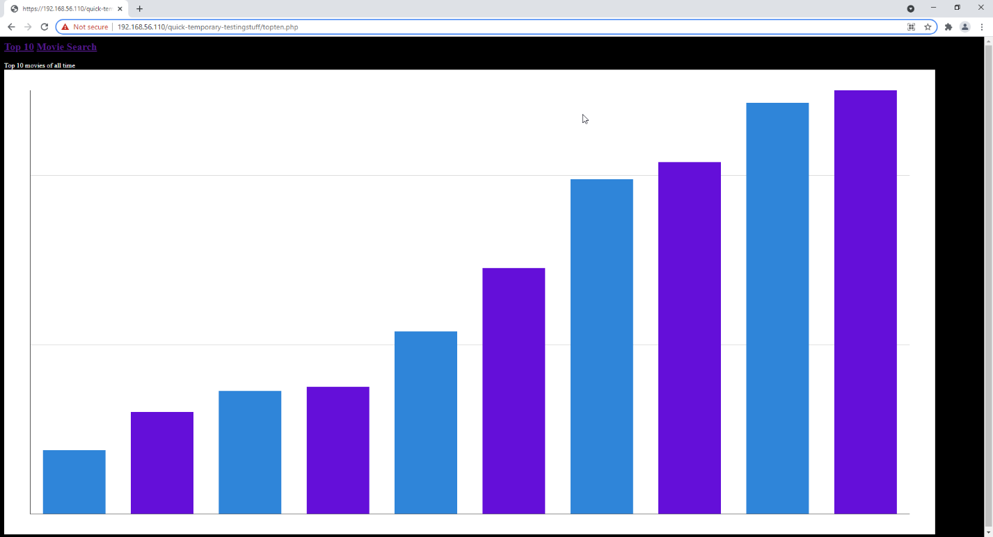

1. Original styling for Graph

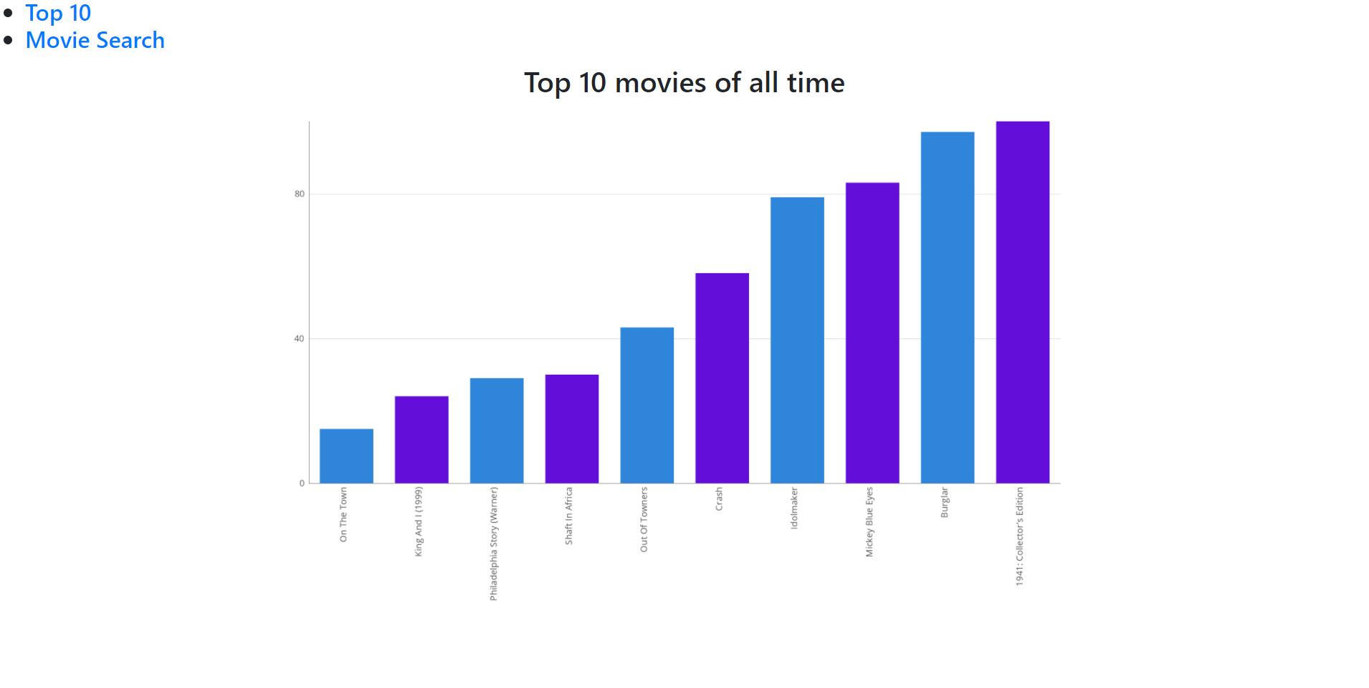

2. New Styling for Graph

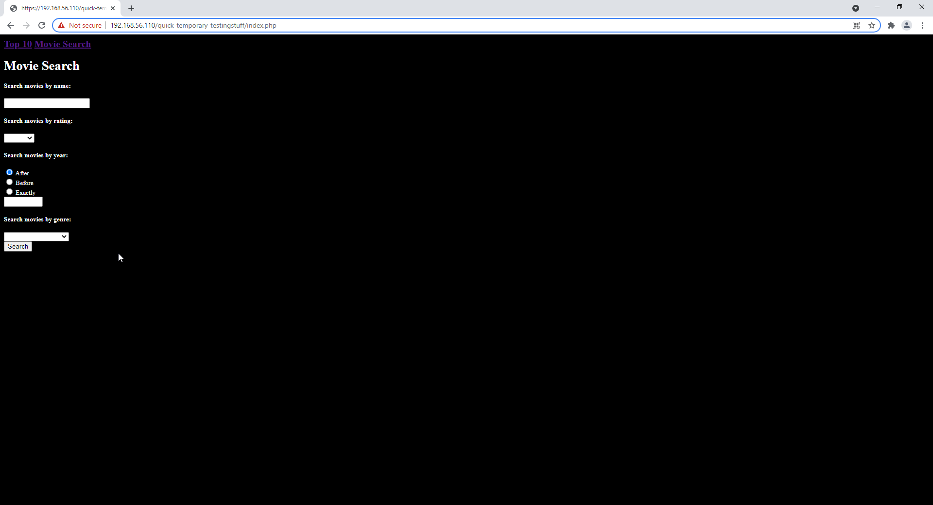

3. Original styling for search page

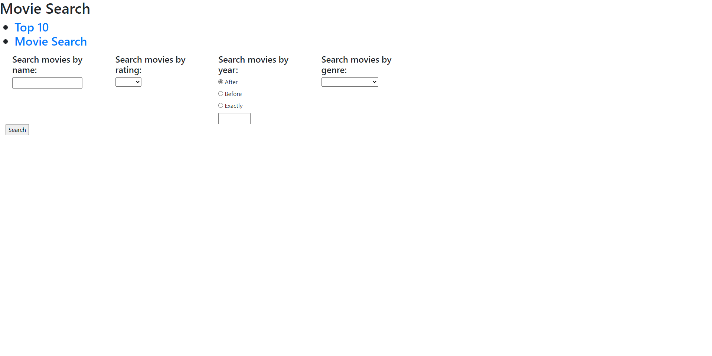

4. New styling for search page

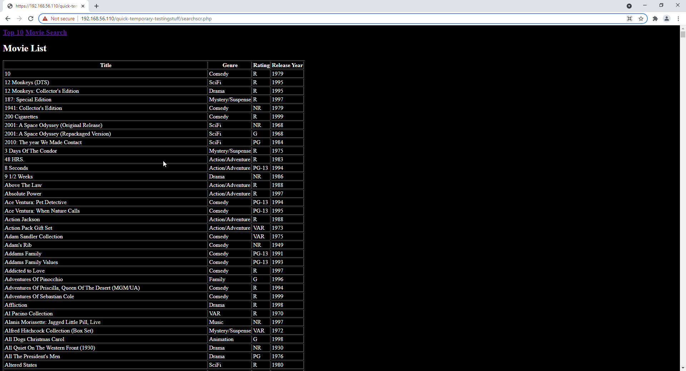

5. Original styling for search results page

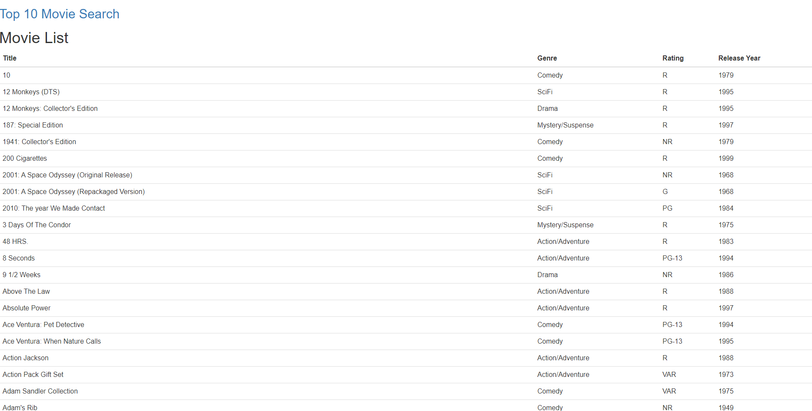

6. New styling for search results page

## Styling comments

The new style improves on the layout and visual pleasantness of the pages. The new style is still subject to change and may include more complex colors and fonts to match user requirements.